**Assignment 5**

**Working with S3:**

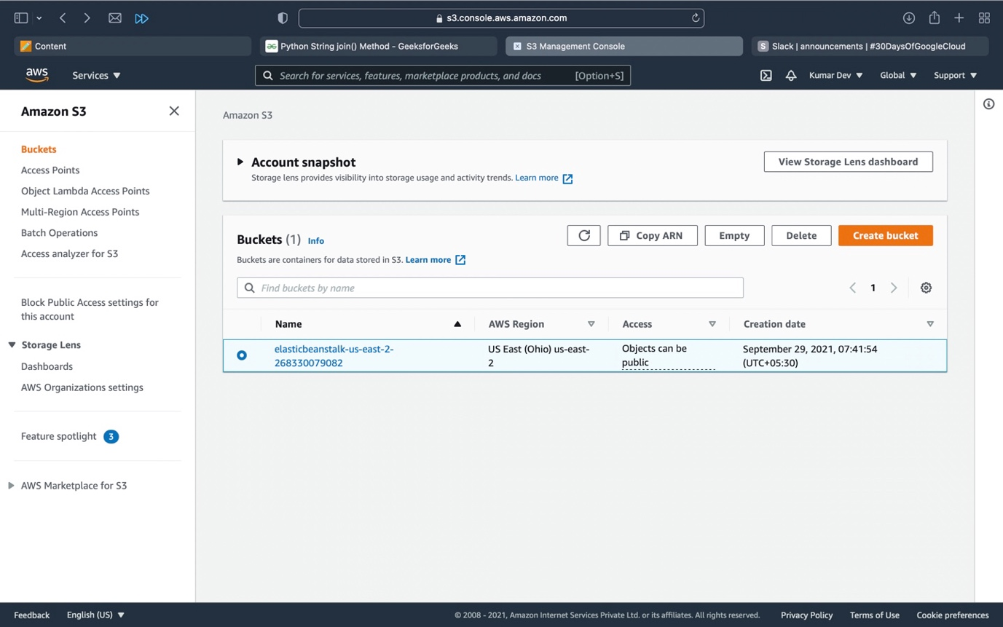

Click on create bucket for creating the buckets.

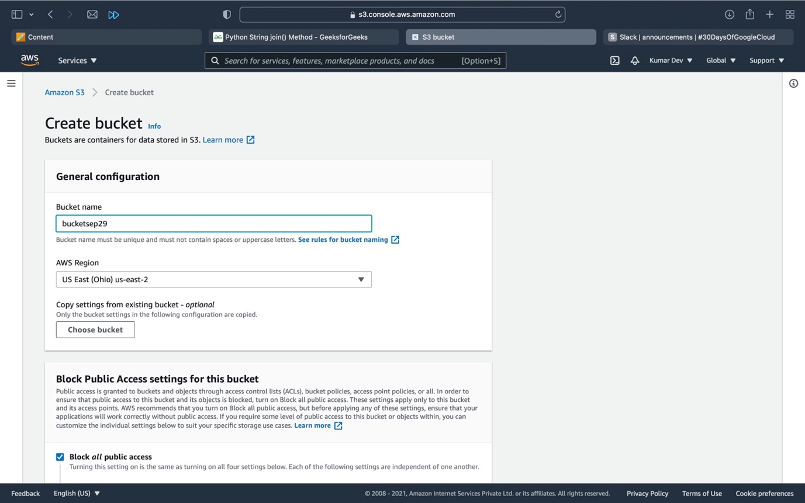

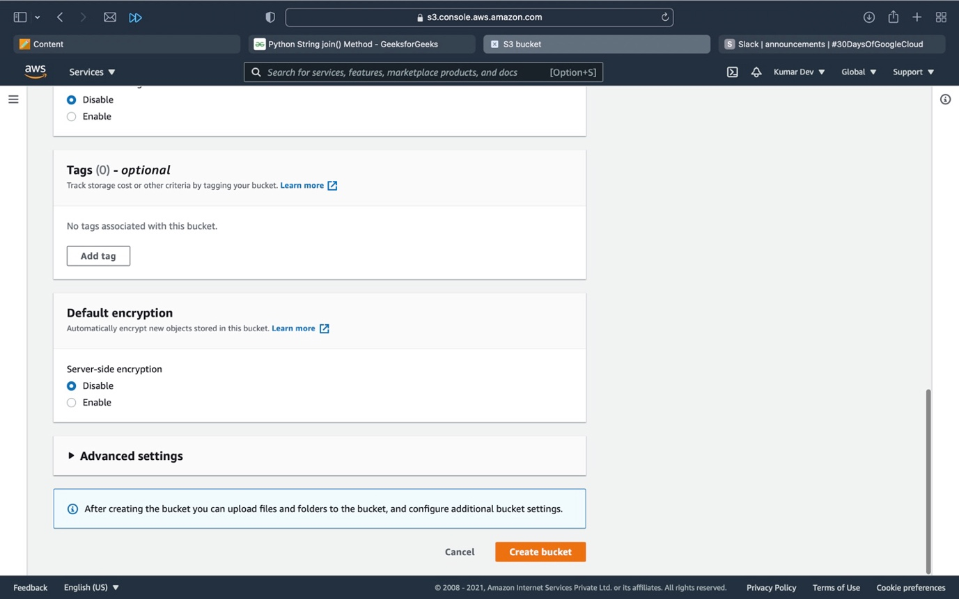

Here give the bucket Name and there are some permissions then click on crate bucket, the bucket will be created.

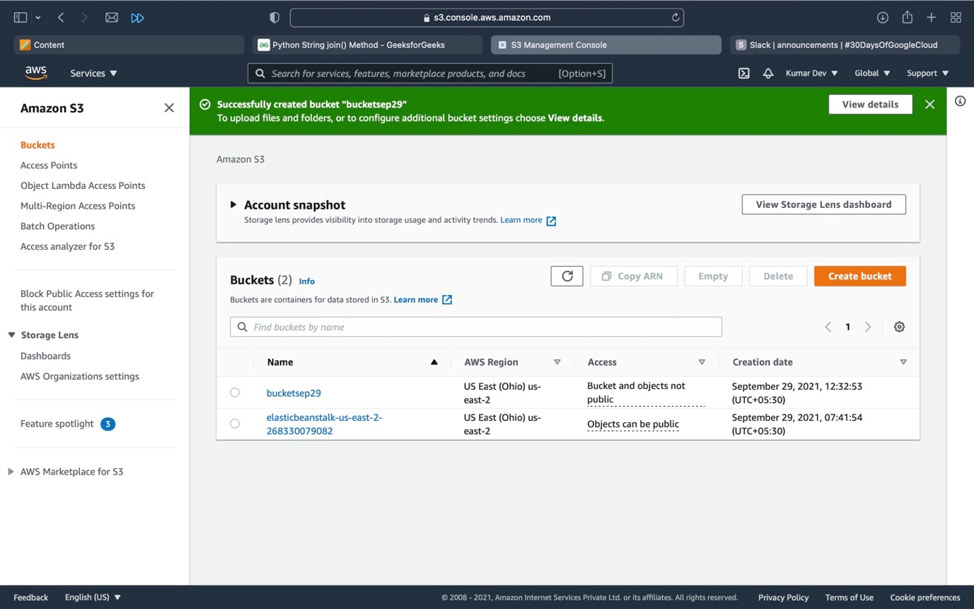

Bucket is Finally created.

**To upload the object into a Bucket.**

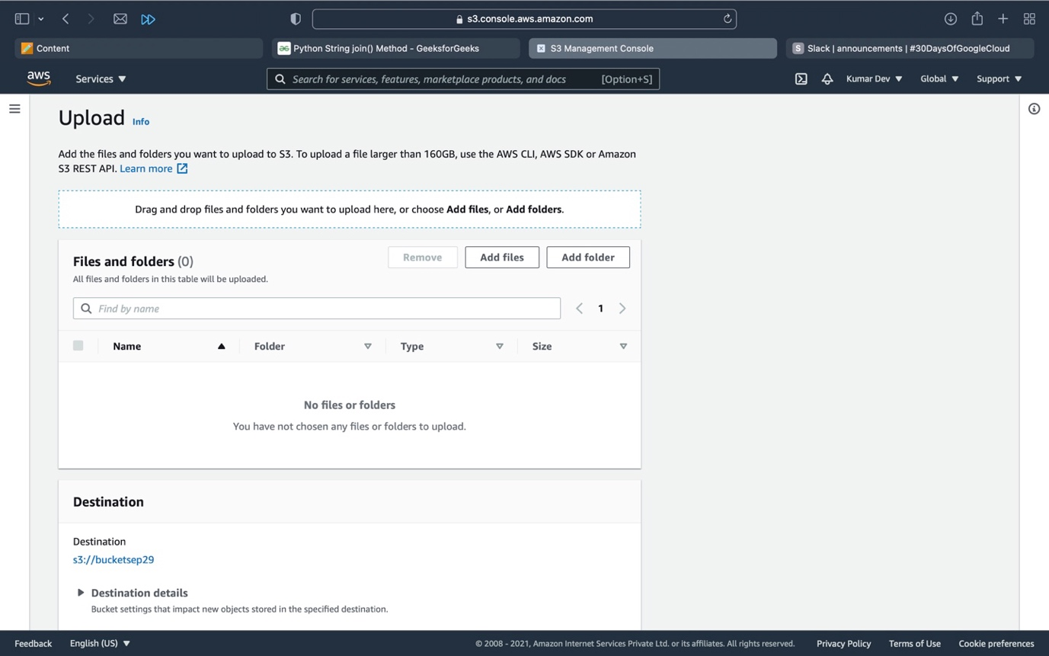

Click on add files to upload object and then click on upload.

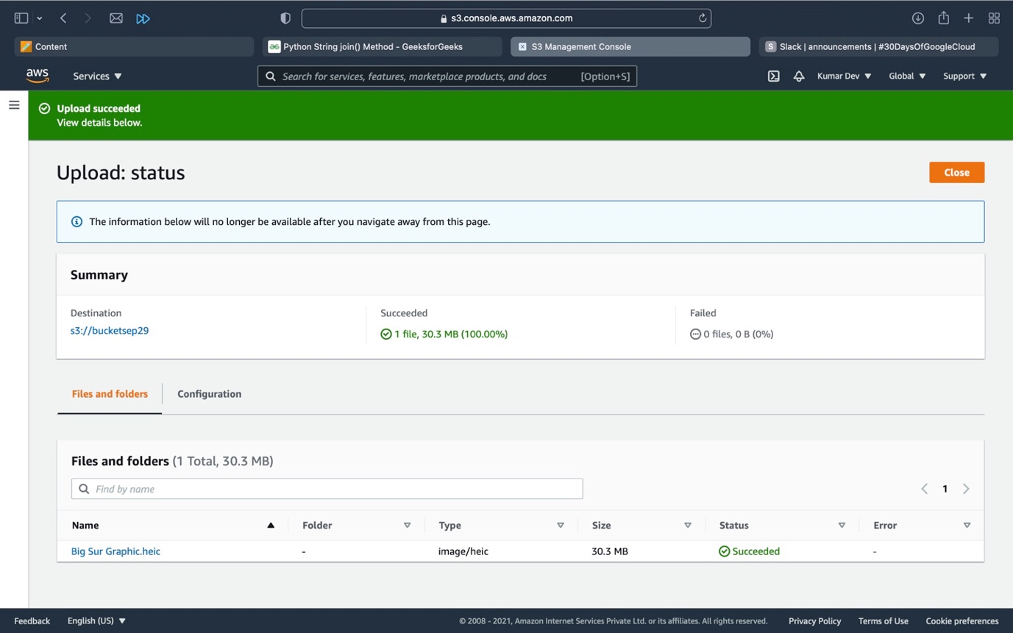

**Object is Uploaded.**

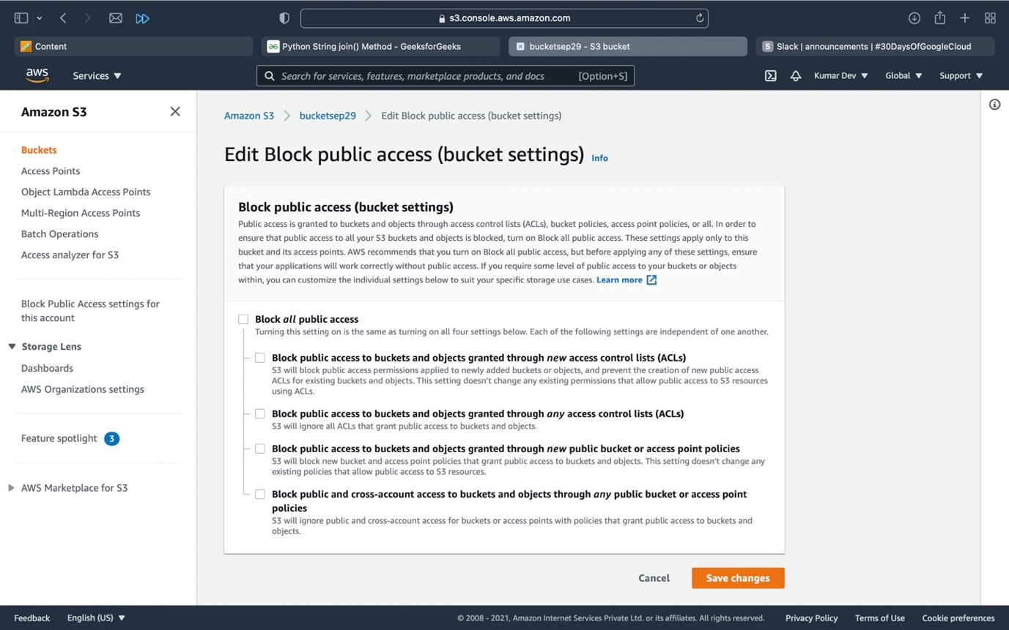

Uncheck Block all public access (for bucket settings) and then click on save changes.

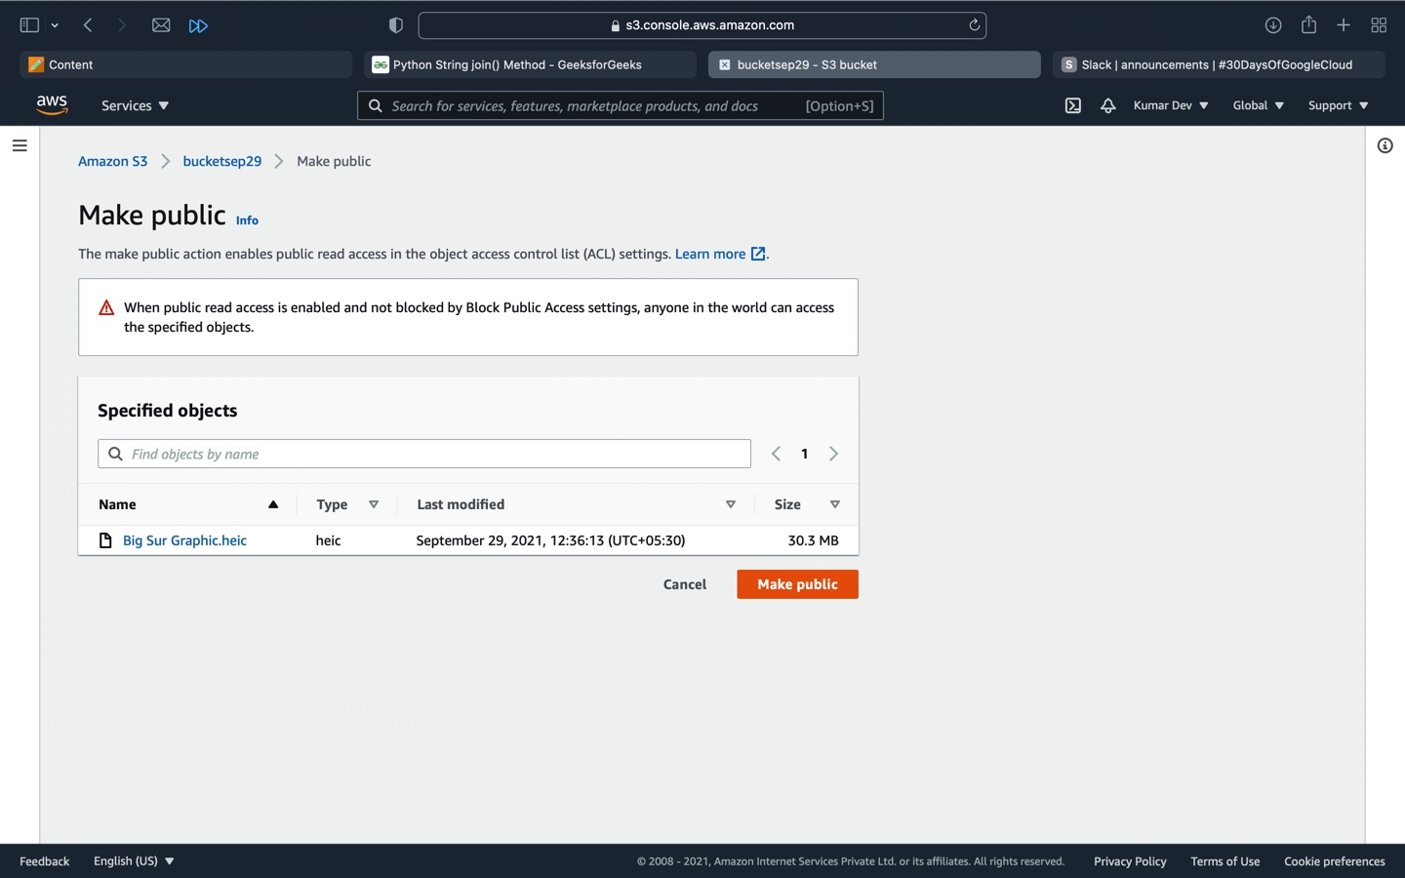

Make object as public.

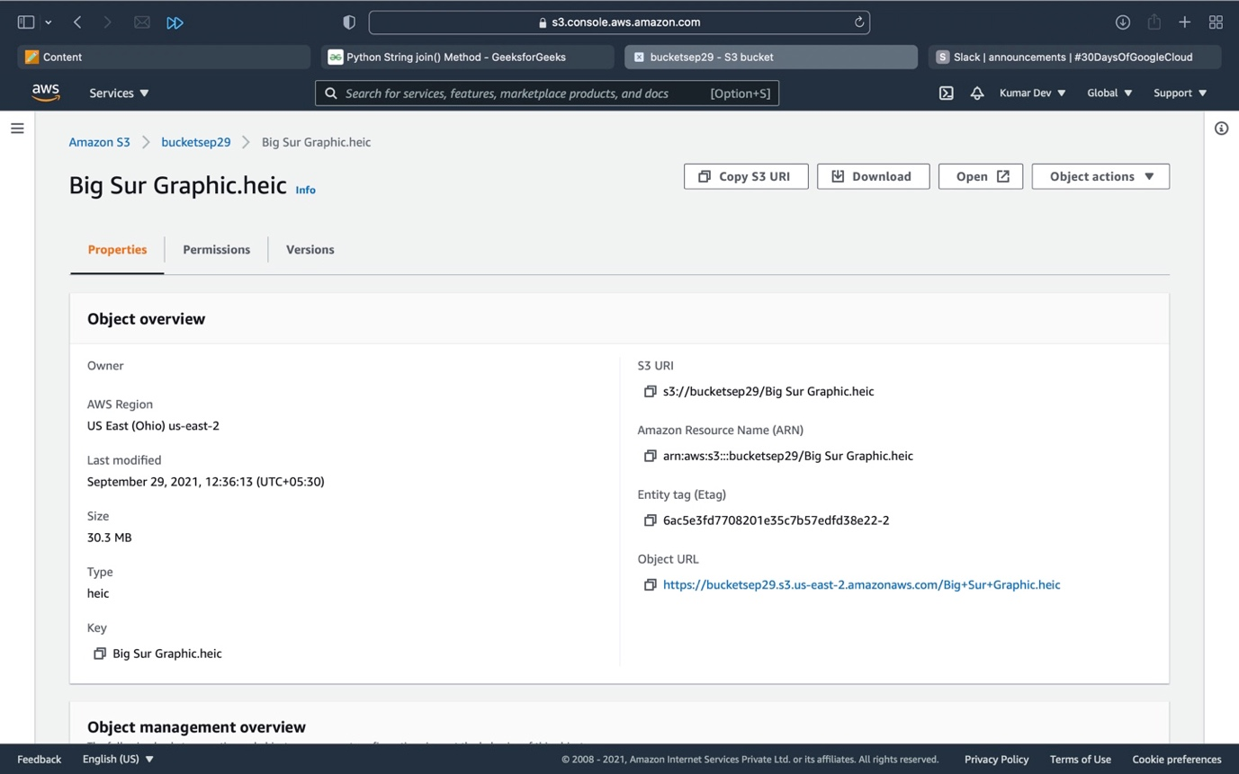

**So, the bucket and object both are public accessed so this can be accessed through object URL.**